MintCraft

-Kartik Khatri

500102128

**Table of Contents**

1. Introduction
   1. Background
   2. Overall Description
   3. Environmental Characteristics
      1. Hardware
      2. Peripherals
      3. People
   4. Interfaces
      1. Interface with User
   5. Constraints
2. Functional Requirements
3. Design Diagrams
4. Miscellaneous

# INTRODUCTION

## BACKGROUND

## 

The digital landscape is constantly evolving, and the concept of ownership is being redefined. MintCraft emerges from this transformative space, recognizing the immense potential of Non-Fungible Tokens (NFTs) to revolutionize how we value and interact with digital creations. We believe NFTs hold the power to unlock a new era of digital ownership, fostering a vibrant community of creators and collectors. MintCraft was born from the desire to bridge the gap between creators and collectors, providing a secure and user-friendly platform for anyone to explore the exciting world of NFTs. Whether you're an artist showcasing your digital masterpiece or a collector seeking unique digital treasures, MintCraft empowers you to participate in this burgeoning space. We envision MintCraft as a launchpad for creativity and a hub for passionate collectors, fostering a space where value is demonstrably attached to digital assets and communities thrive around shared interests.

## DESCRIPTION

Dive into the world of unique digital ownership with MintCraft, your one-stop NFT marketplace! Whether you're a seasoned collector or a curious newcomer, MintCraft empowers you to discover, buy, and even create your own NFTs. Explore a vibrant marketplace teeming with diverse NFT categories, from captivating digital art and musical masterpieces to thrilling gaming items and collectible treasures. Our intuitive interface makes browsing NFTs a breeze. Refine your search with detailed filters and sort by what sparks your interest. Delve into captivating NFT details pages to learn the stories behind each creation. Feeling inspired? MintCraft empowers you to seamlessly create and upload your own NFTs, transforming your digital artwork or collectibles into secure, verifiable assets. With a focus on user-friendliness and security, MintCraft fosters a thriving NFT community where creators and collectors connect and celebrate the power of digital ownership. So, join the movement and unleash the potential of your creativity with MintCraft!

## ENVIRONMENTAL CHARACTERISTICS

### Hardware:

* **Desktop or Laptop computer with internet access:** MintCraft is a web-based platform accessible through a standard web browser.
* While not requiring high-end specs, users should have a computer capable of smoothly displaying images and navigating the marketplace.

### Peripherals:

* Input: **Standard mouse and keyboard:** Basic navigation and interaction with the platform.
* Output: The results and guidance should show up right on your web browser screen, easy to understand and follow.

### Intended user base:

* **Art enthusiasts, collectors, and creators:** MintCraft caters to users interested in digital art, music, and collectibles, providing a platform to discover, buy, sell, and create NFTs.
* **Gamers and in-game item enthusiasts:** The marketplace can support buying, selling, and showcasing NFTs related to video games and virtual items.
* **Anyone interested in the digital ownership space (cryptocurrency enthusiasts):** MintCraft is open to anyone curious about NFTs and exploring the potential of digital ownership.

## INTERFACES

### Interface with User (UI - User Interface)

This is the graphical interface that the user interacts with directly on their smartphone or tablet. It would likely include elements like:

* Home Page
* Featured Products
* Feedback Form

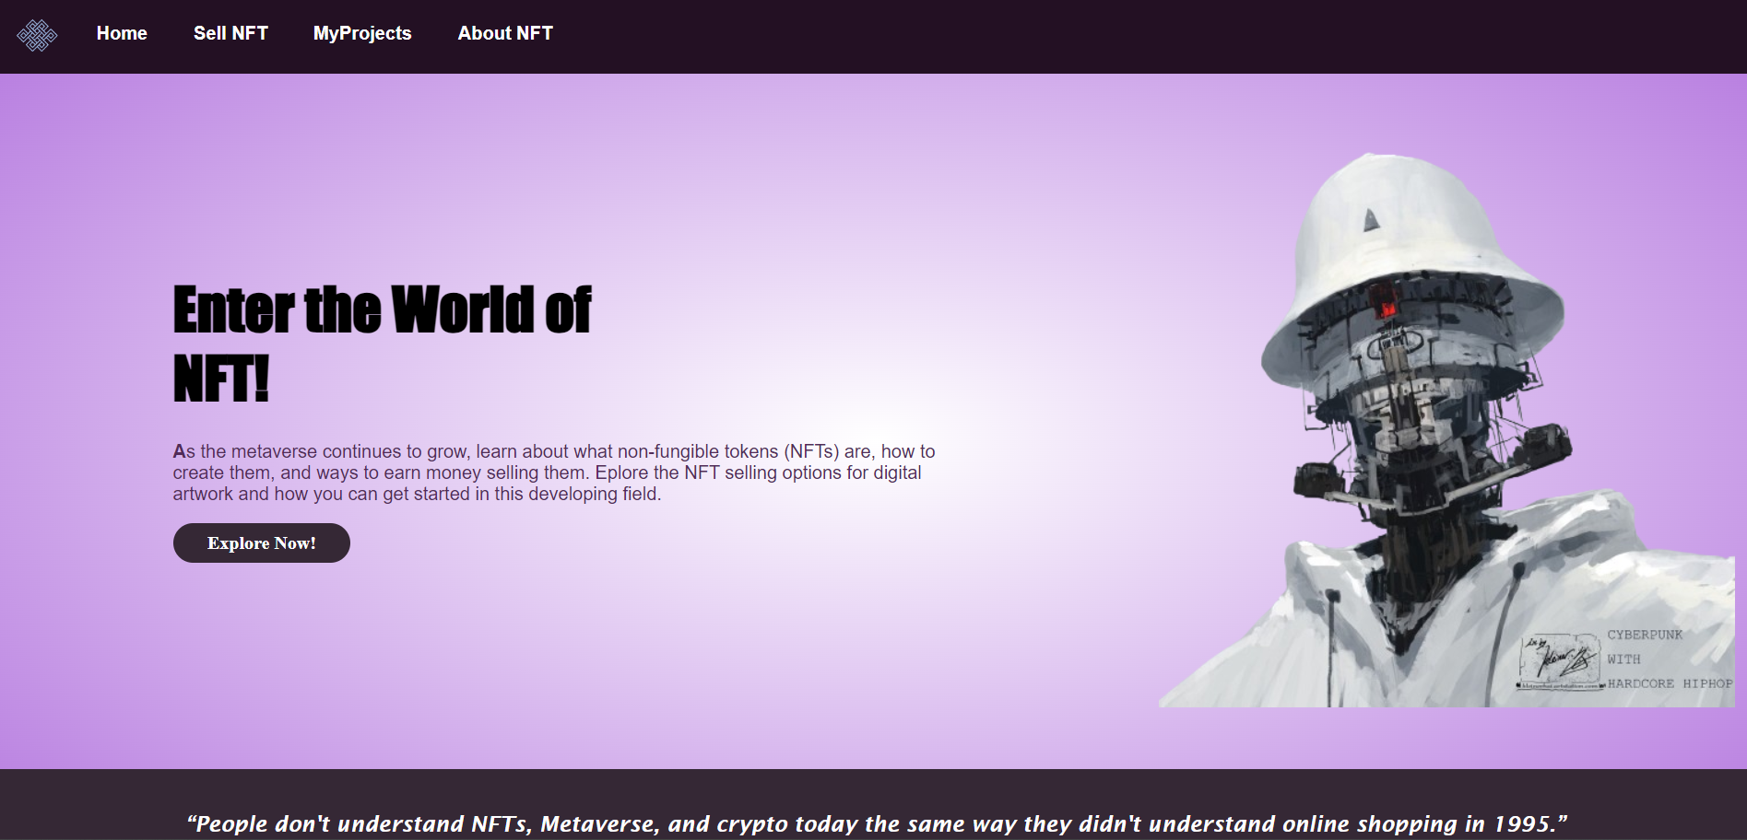

• **Start with the "About Section":** This section provides a clear explanation of what MintCraft is and the basics of NFTs.

• **Explore the "Featured Collections":** This gives you a taste of the diverse NFT categories available and can spark your interest.

• **Browse by Category:** Find NFTs that align with your interests, whether it's art, music, gaming, or something else entirely.

• **Utilize the Filters and Sorting Options:** Narrow down your search to find NFTs that meet your specific criteria (e.g., price range, recently listed).

## CONSTRAINTS

* **Platform Limitation: MintCraft is a web-based platform.** While accessible from various devices, it may not offer the full functionality or immersive experience available in dedicated mobile apps.
* **Limited Data Persistence: MintCraft may have limitations on how much user data is stored long-term.** This could impact features like extensive purchase history or personalized recommendations.
* **Reduced Personalization: Due to limitations on data persistence, MintCraft may offer a reduced level of personalization.** Recommendations and suggestions might be less tailored to your specific interests.
* **No Past Tracking: MintCraft may not track your past browsing history or search preferences.** This could affect the ability to suggest similar NFTs you might be interested in.
* **No Data Reporting: MintCraft may have limitations on generating detailed reports on user behavior or browsing trends.** This could impact marketing efforts or platform improvements based on user data.

# FUNCTIONAL REQUIREMENTS

* **User Input:** Users should be able to create an account and profile

Provide options to upload digital assets (images, audio, video) for NFT creation.

Allow users to input details about their NFTs, including titles, descriptions, and properties.

* NFT Categorisation:- The system should categorize NFTs based on pre-defined categories (e.g., Art, Music, Photography, Gaming). Allow for potential future expansion of categories based on user needs.
* **Personalized Recommendations:** While user data persistence limitations might exist, the system should strive to recommend NFTs based on user browsing history, past purchases, and overall user trends (an anonymized approach).
* **Accessibility and Usability:** The platform should be accessible to users with disabilities, adhering to WCAG (Web Content Accessibility Guidelines) standards. Offer the platform in multiple languages to cater to a broader audience (optional).

# DESIGN DIAGRAMS

## USE-CASE DIAGRAM

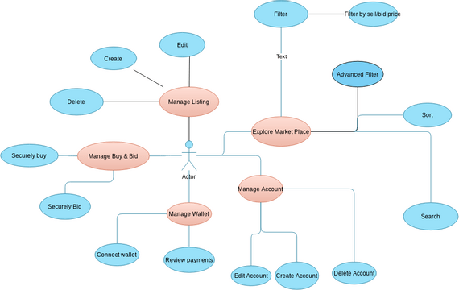

# Miscellaneous

## REFERENCES

1. Simplilearn- youtube channel for the video
2. Investopedia: About NFT